EXPERIMENT

AIM:
To implement a C program to perform Dead Code Elimination on Three Address Code (TAC) by removing statements that do not affect the final output.

ALGORITHM:
- Start the program.
- Read Three Address Code statements until END is entered.
- Separate the left-hand side (LHS) and right-hand side (RHS) of each statement.
- Initialize all statements as not live.
- Scan the statements in reverse order.
- Mark statements as live if their results are required by other live statements or are externally visible.
- Mark earlier variable definitions used by live statements.
- Print only the live statements.
- Stop the program

PSEUDO CODE:
START
READ TAC statements until END

INITIALIZE all statements as not live

FOR each statement in reverse order IF statement has no assignment
MARK it as live ELSE
CHECK whether its result is needed IF needed
MARK it as live END IF

IF destination is x or y MARK it as live
END IF

IF statement is live
FIND variables used in RHS
MARK their earlier definitions as live END IF
END IF END FOR

PRINT all live statements STOP

PROGRAM:
#include <stdio.h> #include <string.h> #include <ctype.h> #define MAX 100 #define LEN 100
int main() { char code[MAX][LEN]; char lhs[MAX][LEN]; char rhs[MAX][LEN]; int live[MAX] = {0}; int n = 0, i, j; char line[LEN];
printf("Enter Three Address Code statements.\n"); printf("Enter END to finish:\n");
while (n < MAX && fgets(line, sizeof(line), stdin))
{
line[strcspn(line, "\n")] = '\0';

if (strcmp(line, "END") == 0) break;
if (strlen(line) == 0) continue;
strcpy(code[n], line);
char *equal = strchr(line, '='); if (equal != NULL)
{

}
else
{
*equal = '\0';
sscanf(line, "%99s", lhs[n]); strcpy(rhs[n], equal + 1);

} n++;
}
lhs[n][0] = '\0';
rhs[n][0] = '\0';

for (i = n - 1; i >= 0; i--)
{
if (lhs[i][0] == '\0')
{
live[i] = 1; continue;
}

int needed = 0;

for (j = i + 1; j < n; j++)
{
if (live[j] && strcmp(lhs[i], lhs[j]) == 0)
{
needed = 1; break;
}
}

if (needed)
live[i] = 1;

if (strcmp(lhs[i], "x") == 0 ||
strcmp(lhs[i], "y") == 0) live[i] = 1;
if (live[i])
{

char *p = rhs[i];

while (*p)
{
if (isalpha((unsigned char)*p) || *p == '_')
{
char var[LEN]; int k = 0;
while (isalnum((unsigned char)*p) ||
*p == '_') var[k++] = *p++;
var[k] = '\0';

for (j = i - 1; j >= 0; j--)
{
if (strcmp(lhs[j], var) == 0)
{
live[j] = 1; break;
}
}
}
else
{
p++;
}
}
}
}

printf("\nOptimized Three Address Code:\n"); for (i = 0; i < n; i++)

{
if (live[i])
printf("%s\n", code[i]);
}

return 0;

}

OUT PUT:
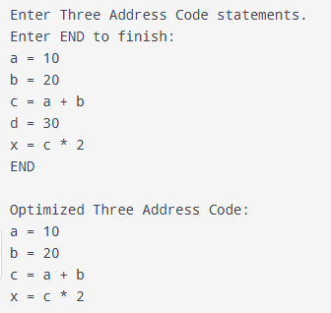

RESULT:
Thus, the C program for Dead Code Elimination in Three Address Code was implemented and executed successfully. It identifies live statements and removes unnecessary assignments.

